“Wildlife Species Categorization System”

A Database Project
Presented to the Faculty of the
College of Information and Computing Sciences in
Mindanao State University

In Partial Fulfillment of the Requirements
for the degree of Bachelor of Science in Information Technology Major in Database System / Networking System

By:
Bayabao, Johayr Cosain
Gampong, Abdul Malik Gampong
Sapio, John Hero Sabalo

Submitted to:
Professor Amer Hussien Macatotong

May 04, 2025

Project Overview

I. Introduction
The necessity for organized wildlife data collection and classification has reached its peak because biodiversity loss and habitat destruction continue to rise. The precise and organized collection of animal species data together with their habitat information serves as the foundation for conservation efforts and ecological research and environmental policy development. The current wildlife management needs more advanced monitoring methods than traditional species monitoring techniques that use paper records and incomplete datasets.

The Wildlife Species Categorization System establishes a relational database structure to properly classify wildlife species through their fundamental ecological and biological features. The system includes classification of species into feeding categories (herbivore, carnivore, omnivore) as well as their scientific and common names and conservation status (endangered or otherwise) and their actual habitat locations. Researchers together with conservationists and environmental organizations can improve their understanding of animal populations and ecological processes through a structured database that clearly defines and connects these factors.

The system implements essential database normalization and referential integrity principles to maintain data consistency and accuracy. The system aims to create an easy-to-use framework that will serve as a foundation for developing more extensive applications including wildlife monitoring systems and biodiversity dashboards and ecological risk assessments. A sound digital infrastructure for species information has become essential because of growing global biodiversity threats.

II. Objective
The main purpose of this research is to develop a relational database system that enables systematic classification and efficient grouping of wildlife species based on their biological characteristics and ecological context. This project aims to enhance the availability and accuracy and scalability of biodiversity-related information to meet the information needs of scholarly scholars, ecologists, nature conservators, and policymakers.
The current rapid rate of biodiversity loss requires efficient wildlife data systems to support evidence-based conservation efforts. The majority of species and habitat data exists across multiple platforms using non-standardized formats. This project aims to resolve these problems through the development of a centralized database system with logical structure and scalability features for future growth and integration capabilities.
Specifically, this study aims to:
1. The database schema should be thoroughly normalized to maintain essential information about species including taxonomic classification, scientific name, habitat location and endangerment status.
2. The system should establish exact relationships between species and habitat and category entities to enable efficient relational mapping and minimize data redundancy.
3. The system should enable users to easily perform queries and data filtering of species based on category (e.g., carnivorous), habitat (e.g., rainforest), or endangerment status for ecological research and wildlife management purposes.
4. The system should provide a base for future integration with sophisticated systems which include GIS-based mapping software, conservation tracking sites and mobile data collection applications.
The system will serve as an effective tool for conservation planning and wildlife diversity protection awareness through its data-based functionality.

III. Key features
The WSCS includes several important features that make it practical for use in ecological data management while allowing some degree of flexibility for future growth. Those features reflect fundamental traits of databases like integrity, normalization and relation-mapping.
- Species Metadata Management
The system contains rich metadata for every species, such as nickname, binomial name, diet type, and endangered level. This well-ordered metadata also makes it possible to classify, filter, and compare species.
- Biological Classification of Species
In this way, each species is labeled as carnivore, herbivore, or omnivore, permitting users to investigate patterns of diet, ecological roles, and relationships among species. Both the study of biology and research on ecology are served by this.
- Identification and Mapping of Habitat
Habitat / relative location Each species entry is tied to a particular habitat, with the habitat located both by name and in relation to other locations. This species-to-environmental mapping allows a better look into habitat-specific biodiversity and provides a means to follow-up on long-term ecosystem shifts.
- Relational Database Structure
It has a normalized relational model with foreign-key relationships between species and its category table, and a habitat table. This model improves the query processing, avoids insertion anomaly and updates anomalies consumes fewer storage space and preserves referential integrity.
- Endangered Status Tracking
A binary field (Is_Endangered) differentiate if a species is endangered or not. This function is useful for conservation analysis or development of reports for endangered species for certain areas or categories.
- Scalability and Research Integration Capabilities
The architecture is flexible allowing for integration of extra features like species behavior, seasonal cycles or conservation projects in the future. It opens up the possibility for integration with research platforms, mobile survey apps, or visual dashboards too.

- Fast query and retrieval for datasets
Users will be able to search for species based on combined filters, such as “all endangered herbivores in forest habitats” or “carnivores in African ecosystems,” for quick, targeted data access to help with research or conservation strategy planning.
- CRUD Functionality via Admin Panel
An admin table and related functionality have been added to manage system data. Administrators can Create, Read, Update, and Delete (CRUD) records in the species, category, and habitat tables. This ensures that data can be kept current and accurate by authorized personnel only, improving system control and security.

IV. ERD
The Entity-Relationship Diagram (ERD) below illustrates the core structure of the Wildlife Species Categorization System. It presents relational database concepts like normalization, foreign key constraints, and data integrity with defined relationships linking the three key tables: category, habitat, and species. And, it now includes the admin entity for managing database records.
- The category table includes a unique Category_ID as well as Category_Name that defines whether a species is a certain carnivore, herbivore, or omnivore.
- The habitat table stores for Habitat_ID, Habitat_Name, and also Habitat_Location. This information gives details concerning locations where various species are commonly found.
- The central species table captures specific animal information including Species_ID, Species_Name, Species_Sci_Name (scientific name), Is_Endangered (binary: 1 for endangered, 0 for not), and foreign keys Category_ID and Habitat_ID that establish links to their respective tables.
- The admin table manages administrative access and includes Admin_ID as the primary key, along with Admin_Username and Admin_Password. This table enables authorized users to perform Create, Read, Update, and Delete (CRUD) operations on species, category, and habitat records, supporting data accuracy and controlled system maintenance.
This relational structure ensures that data is organized, avoids redundancy, and allows efficient querying of species by category, habitat, or conservation status. The ERD acts as a visual blueprint for understanding how data flows and interacts within the system.
Figure 1: Entity-Relationship Diagram of the Wildlife Species Categorization System
(This diagram shows the relational connections between species, category, and habitat, supporting scalable and accurate data organization.)
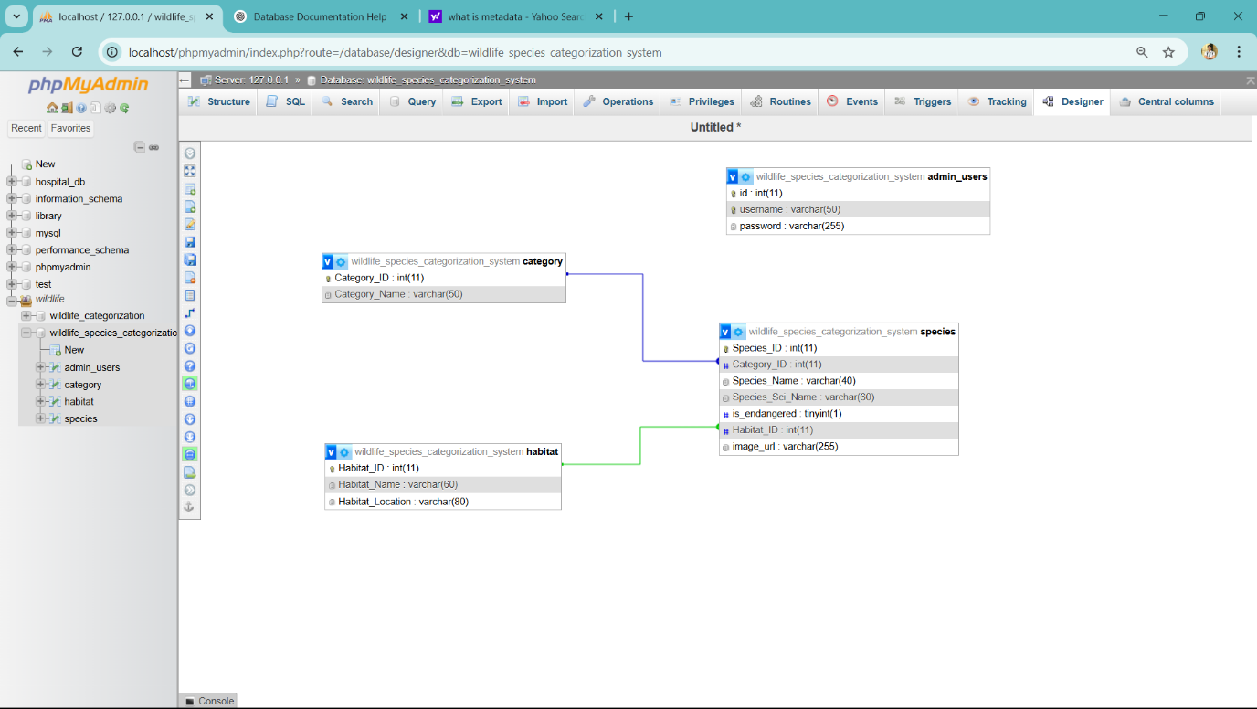

V. Technologies implemented (if applicable)
For better functionality, performance, and user interface of the Wildlife Species Categorization System, the following technologies were integrated:
PHP (Hypertext Preprocessor):
PHP was used as the server-side scripting language for opening a connection with the MySQL database, executing data retrieval, and processing user-initiated search and filter queries. It allows for the dynamic creation of web content through database responses and user input.
MySQL:
MySQL is the relational database management system (RDBMS) used to store all species, category, and habitat-related information. It accommodates relational operations and complex queries that enable effective filtering, sorting, and retrieval of data.
HTML, CSS, and JavaScript:
These were the fundamental web development technologies applied to create the front-end interface:
- HTML supplies the semantic structure of the webpage.
- CSS is utilized for styling and laying out the formatting, such as the sidebar, cards, buttons, and backgrounds.
- JavaScript provides interactivity, including UI component toggling and dynamic filtering of species cards according to checked checkboxes.
Custom Fonts and Background Images:
The application includes custom.otf fonts and background images for titles and headers, which help make the user interface unique and aesthetically pleasing.
This union of technologies makes the system not only scalable and functional but also intuitive and visually appealing. It accommodates real-time interactivity, responsive filtering, and data structure presentation, which makes it ideal for educational and conservation-associated usage.
Admin Panel for CRUD Operations:
A secured admin interface was developed to allow authorized users to add, update, and delete records in the database. This panel includes login authentication, form validation, and alert messages for transaction status (success, error, etc.).

